**EXP NO: 07 Autopsy to investigate artifacts from a disk image NAME : ADHIYAN PERIYAR R P**

**DATE: 21/08/2025 ROLL NO : 231901002**

**AIM:**

Ready for a challenge? Use Autopsy to investigate artifacts from a disk image.

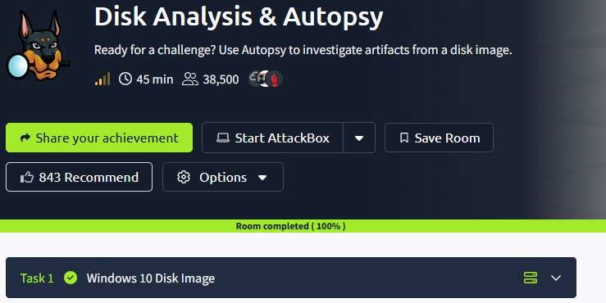

**Task 1 : Windows 10 Disk Image**

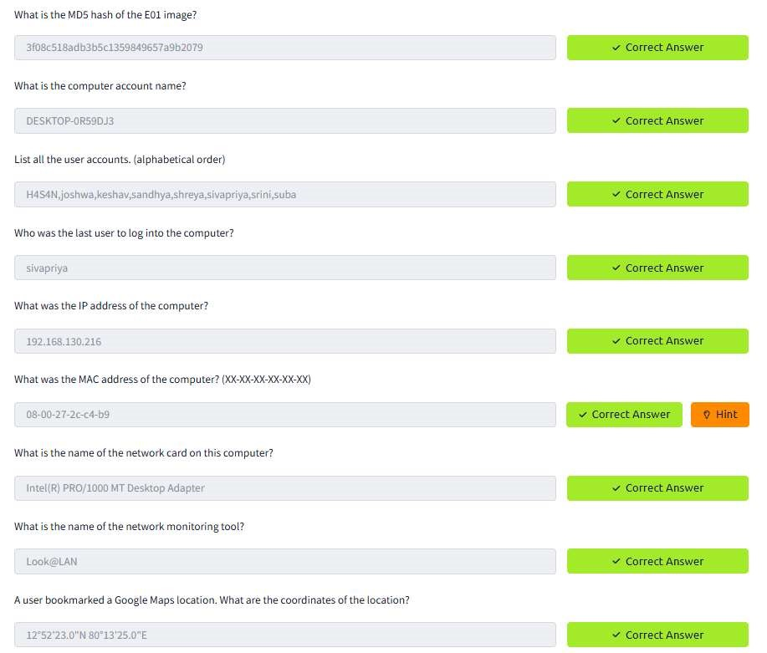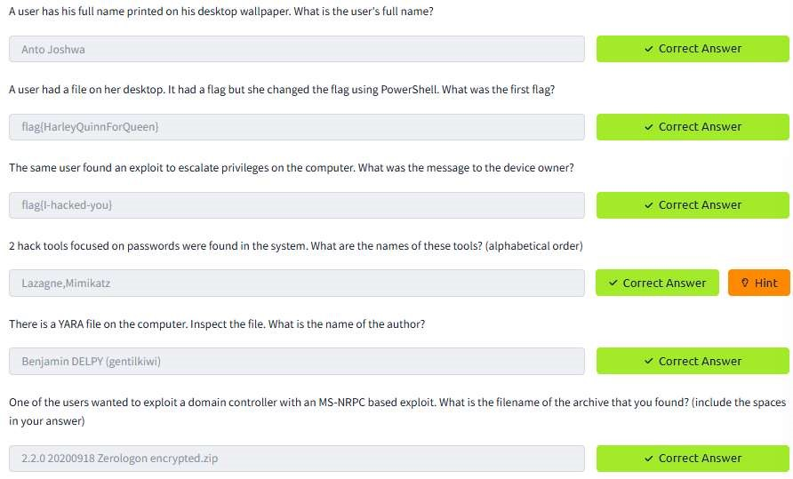

**RESULT :**

Autopsy to investigate artifacts from a disk image is successfully completed in tryhackme platform.